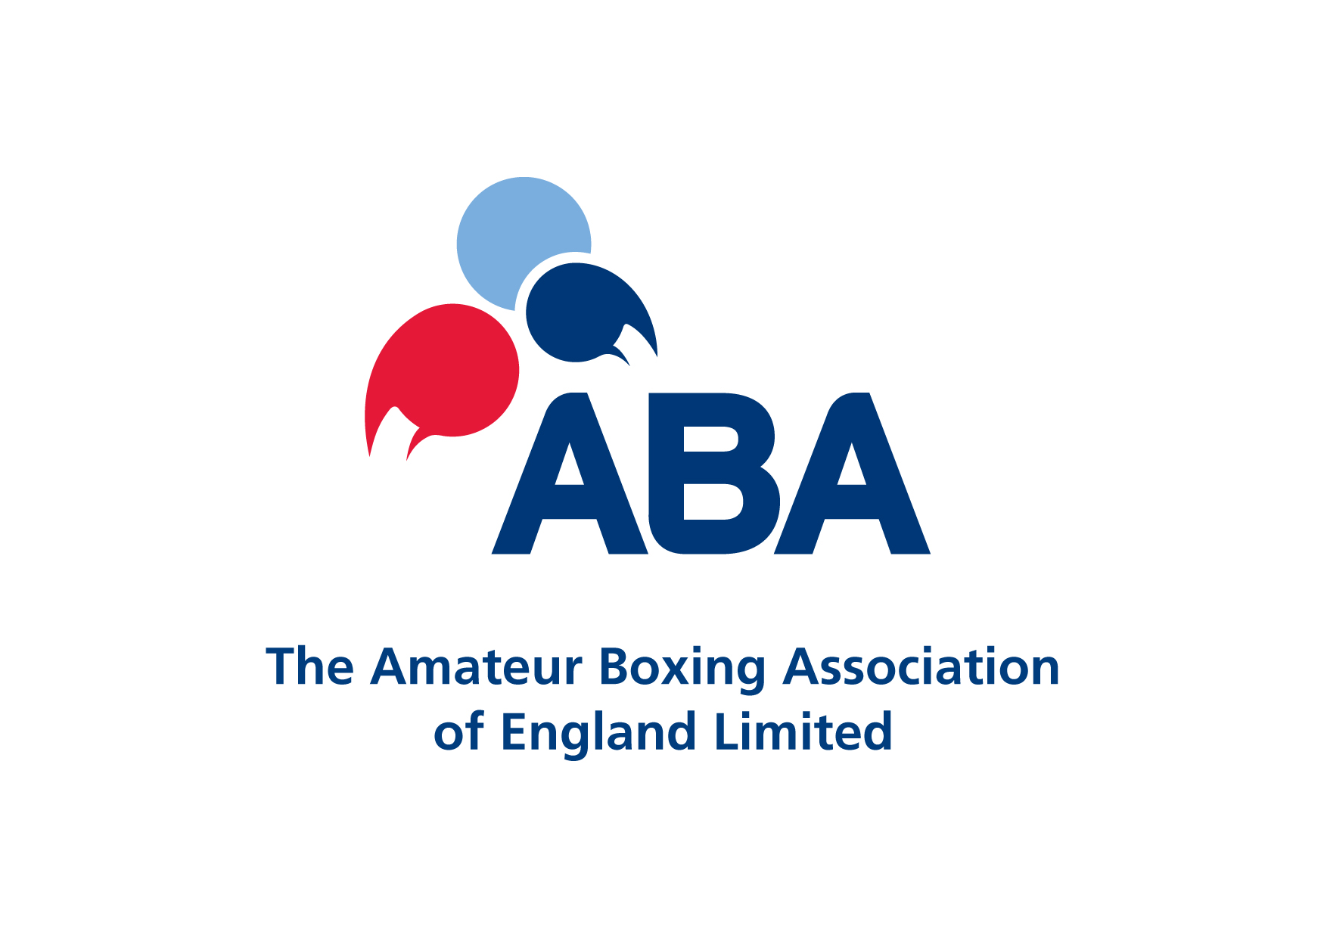
EXPENSES CLAIM FORM (NON-MILEAGE)

NAME IN FULL_________________________________________________________________

ADDRESS_____________________________________________________________________

_____________________________________________________________________________

TELEPHONE __________________________ EMAIL_________________________________

TOTAL AMOUNT CLAIMED £
................................................

To be completed in accordance with ABAE Policy. Please use block capitals for clarity

Receipts MUST be provided to support each element of the claim. Failure to do so will result in your claim being rejected or amended.

I certify that:
- All the particulars set out by me on this form are correct
- In all cases, expenditure has been incurred solely in respect of my appointed ABAE duties
- All accommodation cost claims have prior agreement with ABAE
- Mileage claims must be submitted using the ABAE Mileage Claim form.

CLAIMANT SIGNATURE |  | AUTHORISED ABAE SIGNATORY
Signed: |  | Signed:
Date: |  | Date:
Name: |  | Name:
(BLOCK CAPITALS) (BLOCK CAPITALS)

Bank details should be provided for each claim made as previous details are stored for a limited period due to Data protection reasons. All expenses are paid by BACS electronic transfer

Bank Name: |  | Account Name :
Account Number  (8 digits) |  | Sort Code:  (6 digits)

Is this a new bank account since your last claim YES/NO

FOR OFFICE USE ONLY:
DATE  Of EVENT | DETAILS OF EVENT/COURSE/MEETING FOR WHICH SPEND INCURRED,  including Location  (IE Junior Novice Semi finals, Sheffield/Schoolboys Squad Training, Liverpool/CTS Course/Council Meeting etc) | YOUR ROLE AT EVENT  (ie OIC/Boxer/ Meeting Delegate etc) | DETAIL/NATURE OF CLAIM.  If Travel expense claim state location travelled from and to.  (IE Train ticket for travel, London Kings Cross to EIS Sheffield/Evening Meal purchase during CTS Course etc etc) | AMOUNT  CLAIMED  £  (attach receipt in all cases)
TOTAL AMOUNT CLAIMED £
(to be completed by claimant)

FOR OFFICE USE ONLY
Nominal | Cost Centre |  | Amount
 |  | £
 |  | £
 |  | £
 |  | £
Total Claimed | (£)
Checked by
All expense forms should be sent to the ABAE Head Office:

ABAE Ltd,
English Institute of Sport,
Coleridge Road,
Sheffield, S9 5DA:

For enquiries: 0114 2235654

